Working with NDIS Participants Experiencing Crisis
Key Strategies for managing complex support needs and crisis

Contents
Aim 3
Overview 4
Introduction 4
Participant Story 4
Working in Crisis Situations 5
Introduction 5
Theory 6
Tools and strategies 7
Considerations for Practice 8
Case study 8
Interagency Collaboration 9
Introduction 9
Tools and strategies 10
Considerations for Practice 11
Case study 12
Integrated Care Team Review 13
Introduction 13
Theory 14
Tools and strategies 15
Considerations for Practice: 15
Case study: 16
Supported Decision Making 17
Introduction 17
Theory 17
Tools and strategies 18
Considerations for Practice: 18
Case study: 19
Planning for Participants 20
Introduction 20
Theory 21
Tools and strategies 21
Considerations for Practice: 22
Case study: 22
Participants who need Support to Engage 23
Introduction 23
Theory 23
Tools and strategies 23
Considerations for Practice: 24
Case Study 25
Intersectionality and Cohorts 26
Aboriginal and Torres Strait Islanders 27
LGBTIQA+ Participants 29
Cultural and Linguistically Diverse (CALD) participants (including those with migrant/refugee background/history) 32
Working with Participants with a Complex Trauma Background 34
Introduction 34
Theory 34
Tools and strategies 35
Consideration for Practice 36
Psychosocial Disability and Mental Health 37
Introduction 37
Theory 37
Tools and strategies 37
Considerations for Practice: 38
Accessing Subject Matter Expertise 39
Introduction 39
Theory 39
Tools and Strategies 39
Considerations for Practice 40
Resource Links 41
References 46

Aim
This guide has been developed as a resource for practitioners who are undertaking Level 2 Coordination of Supports or Level 3 Specialist Support Coordination work with NDIS participants who have complex support needs, who may be experiencing crisis, or at risk of entering a crisis situation that is directly related to, or impacted by their disability related support needs.
For the purpose of this guide, the term “support coordinator” will be used to refer to both coordination of supports and specialist support coordination practitioners.
There are a range of resources available to new or existing support coordinators in relation to the role of support coordinators in supporting NDIS participants to understand, implement and get the best outcome from their NDIS plans. The following are links to these resources that are freely available online;
NDS- Practical Guidance to Operating in the NDIS
This guide seeks to build on these existing resources, through provision of information, resources and tools to increase support coordinators capacity and capability in working with participants with complex support needs. This guide has a strong focus on crisis management and working with participants with exceptionally complex support needs.
Through the use of case studies as well as references to existing best practice resources, this guide will give practitioners the knowledge and tools to ensure that participants regardless of their complex and varied support needs are well supported in their communities.
These guidelines were developed by Marathon Health’s Support Coordinators and the ECSN Specialist Support Coordinators:
Quyen Tran
Lyndal Le Bas
Patricia Klauss
Rene Liebenberg
Shana Turner
Kathryn Webber
Rebecca Glencross
Victoria Turner
Cameron Stott
Emma Mahady
Dean Bright

Overview

Introduction
Welcome to Working with NDIS Participants experiencing crisis.
This document has been developed to support you as a support coordinator who may be working with NDIS participants with multiple and complex needs, or who are at risk of, or are experiencing crisis.
Each section of this guideline seeks to provide a basic introduction to a specific topic, the theory that supports each topic, tools and strategies to support you in your work and a summary of Considerations for practice that may be experienced by support coordinators that you are unlikely to find in any theoretical documents. The topics include:
- Working in Crisis Situations
- Interagency Collaboration
- Complex Case Reviews
- Supported Decision Making
- Planning with Participants
- Working with disengaged or service resistant participants
- Intersectionality and specific cohorts, and;
- How and where to access Subject Matter Expertise
We will follow a case study through many of the sections of the document to assist you in contextualising the theory, tools and strategies to a specific NDIS participant journey.
Let’s introduce you to Jane and David........

Participant Story
Jane is the Support Coordinator for a NDIS participant named David; David currently lives in a Supported Accommodation setting, has community access 3 days a week for 3 hours during the week and on Saturdays attends a social group with different service providers. Additionally, David is connected with an Occupational Therapist and Speech Pathologist. David currently makes his own decisions; however, it is noted that over a number of years guardianship has been explored and declined due to a history of David making good supported decisions.
Over the past few weeks, David has started to display behaviours of concern in his home and in the community resulting in regular poor interactions with mainstream services (Police & Health). David has an Acquired Brain Injury (ABI) and a mental health co-morbidity, he is 47 years old. Furthermore, Jane has identified that David’s support providers do not communicate with each other, resulting in increased stress and demand for the support coordination role.

Working in Crisis Situations

Introduction

What is a crisis?
According to Dictionary.com crisis can be defined as “a dramatic emotional or circumstantial upheaval in a person’s life”.
Often crisis does go hand in hand with complexity, however not all crisis events are borne out of complexity. When considering our own lives, at any point due to unforeseen, unexpected or unavoidable events we can all enter some form of crisis, often at multiple points in our life journeys.
In the same way, when working with our participants we need to recognise that crisis events can occur at any point which may impact on the delivery of supports, the safety and wellbeing of participants and ongoing service provision. We cannot always avoid a crisis from occurring, however we can manage these crisis as they occur, therefore minimising the impact of these events.

Pre-indicators of Crisis
We know that crisis events are often unavoidable, however, we also know that sometimes crisis events are generated through a series of other events or circumstances that led up to the crisis. These might be referred to as pre-cursors or pre-indicators of crisis. Based on previous research and what we have learnt in the ECSN program, the following are some pre-indicators that a crisis may be about to occur:
- Chronic or regular disengagement from formal supports
- Informal support risks eg; older parent carers, family violence
- Lack of appropriate funding or planning that correctly reflects the support needs of the participant
- Poor communication and coordination of services between stakeholders
- Significant behaviours of concern that are impacting service delivery
- Comorbidity of mental health and other disability diagnosis or issues eg; drug and alcohol abuse.
- Chronic or ongoing poor interactions with mainstream services eg; police, health and justice systems.
- Whole of life supports eg; one provider being responsible for delivery of all of a person’s formal supports with no other independent or informal supports involved or overseeing the care arrangements.
Once we learn to start recognising these and other pre-indicators of crisis, we can intervene early to mitigate the risk that the crisis will occur.

Planning to prepare for crisis
Lack of planning or preparation results in confusion, poor or disjointed communication, increased anxiety and generally poorer outcomes, compared to those who have prepared for it.
As practitioners we should always plan for the worst-case scenario and develop at least one contingency or parallel plan with the participants we work with to assist in managing crisis as they occur. This is particularly relevant when working with participants who have some pre-indicators of crisis in their lives.

Theory
There are numerous models of crisis intervention with many focussing on a therapeutic approach to problem solving with the participant. Albert Roberts is widely considered to be a leading authority on crisis intervention and in 1991 developed the Robert’s Seven Stage Crisis Intervention Model 1
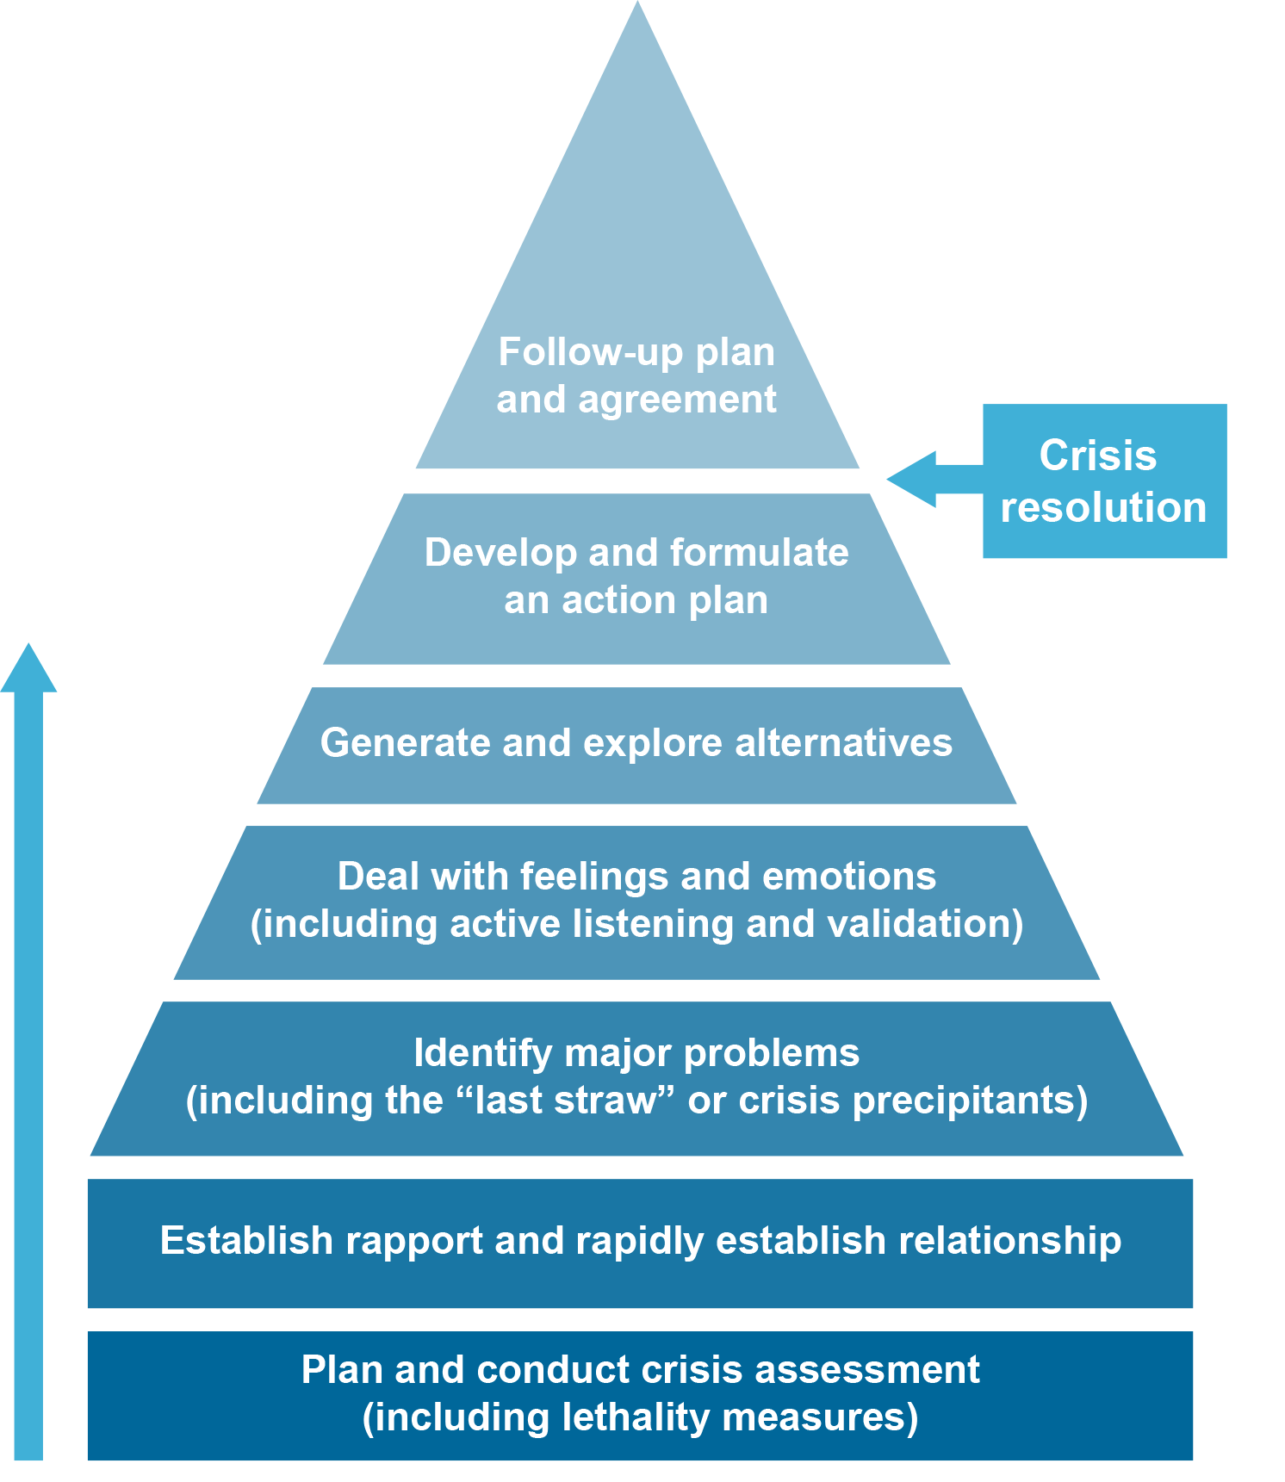
This approach focuses on conducting an initial risk assessment, building a rapport quickly, problem identification, dealing with emotional responses, exploring alternatives and developing action plans with a defined follow up process post crisis.

Roberts, Albert & Ottens, al. (2005). The Seven-Stage Crisis Intervention Model: A Road Map to Goal Attainment, Problem Solving, and Crisis Resolution. Brief Treatment and Crisis Intervention. 5. 10.1093/brief-treatment/mhi030.

Tools and strategies
Regardless of the method of crisis intervention the following core principles should be adhered to in working in crisis situations to ensure the intervention is as successful as possible;
- Simplicity—People respond to simple, not complex things, during a crisis.
- Brevity—Most crisis intervention contacts are short in duration, some lasting only a few minutes. It is typical to have three to five contacts to complete crisis intervention work with an individual.
- Innovation—Crisis Intervention providers must be creative to manage unique and emotionally painful situations.
- Pragmatism—Suggestions must be practical if they are to work in resolving a crisis.
- Proximity—Most effective crisis intervention contacts occur closer to the operational zone or in someone’s comfort zone.
- Immediacy—A crisis reaction demands rapid intervention. Delays cause more pain and complications.
- Expectancy—When possible, the crisis intervener works to set up expectations of a reasonable positive outcome.

How does crisis intervention differ from support coordination?
Whilst support coordinators are required to plan for, prevent and mitigate crisis events, there are key differences between support coordination work and crisis intervention work when crisis events do occur.
Support Coordination | Crisis Intervention
Longer term service provision | One-off/time limited intervention
Focus on stages of NDIS plan implementation | Focus on an event resulting in crisis
Building participant capacity and resilience | May require certain immediate tasks and activities to be undertaken by the practitioner to resolve issues quickly. There is unlikely to be an opportunity to build capacity and resilience in crisis situations.
Choice and control forefront in all decision making related to supports | Some decisions eg; information sharing, service provision may need to be made by others in the best interests of the participant
Undertake regular planned reviews of supports and reflect on outcomes | Undertake immediate post crisis reviews of supports to facilitate adhoc NDIS plan reviews if required.

Considerations for Practice

Managing Emotional Responses
One of the primary skills of any good crisis worker is to manage often strong emotional responses to crisis situations. These emotions may not only be displayed by the person in crisis but by any stakeholders directly involved in the crisis eg; Hospital ED staff, service providers, family members etc. Using active listening skills and motivational interviewing skills to manage strong emotional responses is the key to progressing good outcomes.
Despite emotions often running strong, the crisis intervener must remain calm and keep everyone focussed on the end result.

Finding Outcomes
Be prepared to accept outcomes that may not necessarily be the one you were aiming for. The end goal in any crisis intervention is to manage the crisis and ensure the safety and wellbeing of the participant. Becoming fixated on one possible outcome can limit your options and you may miss opportunities to resolve the crisis in a timelier manner.

Useful resources for working in crisis
- Action priority matrix
- Risk identification
- Care mapping
- Formulation
- Brain dump

Interagency Collaboration

Introduction

What is collaboration?
Collaboration is the means of producing something joined and new, from the interactions of people and organisations, their knowledge and resources (ARACY, 2009). The aim of collaboration is keeping all involved working together in a coordinated, complementary fashion that avoids pulling the participant in different directions, leaving gaps, using conflicting practice and increasing stress of the participant.

Complex needs: the participant, services and system
To contextualise interagency collaboration, it’s important to acknowledge that providers are players in a bigger system; this system refers to the funding, policies and culture that influences, to varying degrees the way in which the providers deliver services and supports.
The success of any collaboration is dependent on cooperating and functioning within the bounds they can influence.
- Participant level: challenging behaviours, mental illness, substance misuse, complex medical, physical and sensory needs
- Provider Level: guardianship, health, housing and criminal justice, education, NDIS
- System Level: Funding (NDIA), Quality and Safeguarding and Collaboration
Participants with complex supports needs require interagency collaboration as they usually depend on multiple providers and systems for ongoing support. Effective interagency collaboration thereby decreases the possibility of crisis occurring.
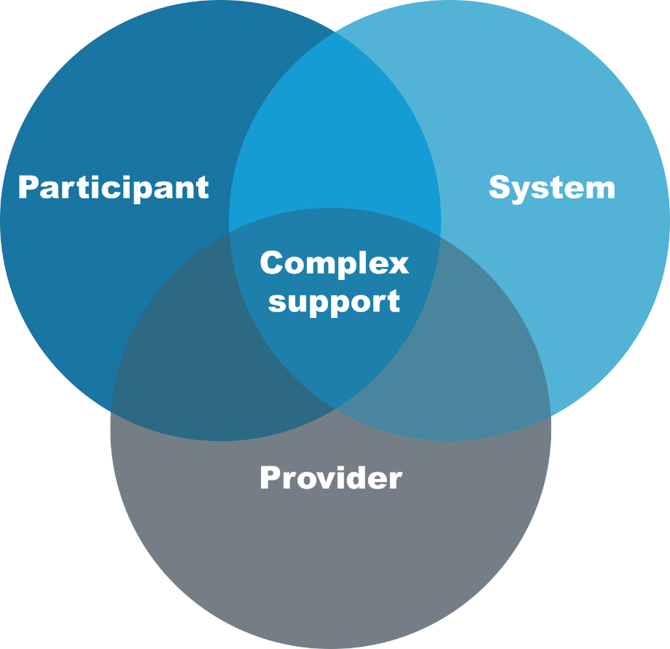
Theory

Cooperation, coordination and collaboration
Cooperation is a good starting point from which to build a more coordinated approach with the ultimate aim to achieve collaboration. Collaboration involves the highest level of interdependence, risk, reward, commitment and contribution in supporting people with complex needs.

Influencing change
The Support Coordination role can be frustrating due to working to balance the participant needs within the systemic restrictions, and having minimal influence to make the changes required. Constantly being in this space can increase stress and fatigue, therefore it is important evaluate the situations where we can influence positive change and where we cannot. The Figure below can be used to determine when to pursue an opportunity to influence systematic, provider or personal change.
 | Can influence | Can’t influence
Act | Pursue Opportunity | Waste Energy
Don’t act | Waste Opportunity | Save Energy

If you are interested to read more about active interagency collaboration please see below links.
- Mental health, police and ambulance collaboration: PACER Report
- Intellectual disability and the police sector: Police Code of Practice

Tools and strategies

Ideas on how to collaborate
The ultimate aim of collaboration is for it to be of benefit to the participant; some of the benefits to participant are outlined below:
- A single point of contact
- Being properly informed (accurate, practical and honest information)
- A relationship of understanding and trust with the coordinator
- Support to exercise choice and control in line with their own goals and priorities
- Timely access to services and supports
- Confidence that future needs will be met
- Service providers with the necessary knowledge and expertise
- Consistent information provided to service providers”
(Madden, Fortune, Collings and Madden, 2014, p.7)

Overlapping responsibilities & COAG
The COAG document (here) outlines the responsibilities of different mainstream service systems as they relate to the NDIS, and vice versa. It is a useful exercise to become familiar with these principles when planning with a complex participant in order to know what is the responsibility and limitation of the NDIS and other services systems (like Justice, Education, Mental Health, etc). Not only does it build your knowledge and give you tools to effectively plan and connect the participant to services and supports, it can also be used to identify areas of responsibility or linkages to multiple services to best support your participant stakeholders and working together in a cooperative spirit that focuses on keeping the participant at the centre of all decision making, whilst still operating within the rules. You can liken it to standing inside the box, but thinking outside of it!

Getting to know key contacts
The recognition of the complexities around interagency collaboration is demonstrated by the creation of roles to assist with the process. It’s worth getting to know the key contacts who can assist you with interagency collaboration. Some of these roles include:
- Health Liaison Officers (NDIA)
- NDIS Transition Leads (Health Service)
- Justice Liaison Officers (Justice)
- Aboriginal Liaison Officers (Justice, Health and Mental Health)

Considerations for Practice

Relationships and Knowledge
The keys to increasing successful interagency collaboration is improved relationships and communication between service providers and sectors. Furthermore, a Support Coordinator knowledge of disability and mainstream services availability and suitability for participants is useful when creating collaboration services.

The Coordinator of All Things!
The Support Coordinator is often in the position of being required to coordinate difficult situations and navigate systems usually simultaneously. Furthermore, a Support Coordinator can identify service gaps and while navigating the appropriate system the participant can rely heavily on the support coordinator. If this occurs it is vital that the support coordinator create and maintain boundaries without compromising the support provided to the participants. This can be achieved through:
- Understanding the scope of your role as a Support Coordinator and clearly communicating this with the Participant
- Understand and refer to the COAG
- Ensure familiarity with the rights of the participant, not just from an NDIS and disability perspective, but also in terms of their rights as citizens e.g. tenancy rights and as human beings.

Be clear and accept when things are not within your circle of influence and seek assistance from those who are in a better position e.g. Advocacy services

Billable Time
In the NDIS world service providers have had to adjust to the concept of billable hours and Time. This concept can often impact the size of caseloads, and support coordinators time can be monitored to make sure they make their billable target adding another layer of stress to the role. Working collaboratively can be time consuming and sometimes support coordinators do not have the available funds to continue to work in a collaborative manner.

The Balance
As a Support Coordinator, you often quickly find yourself in the thick of things. There are two strategies here that might be helpful to help move things forward:
- do less – to give more opportunity for others to do more
- giving more time - for others to contribute
There may be a conflict of opinion within the collaboration team about how to best support the participant; it is important to remember that the participant should be at the centre of their support and the risks and benefits from intervention should be discussed. The support coordinator role should be to the provide the opportunity to openly discuss these concerns holistically.

Useful resources for Interagency collaboration
- Communication plans
- Actions plans
- Care mapping

Case study
Jane recognises having a holistic view of David, will assist his support system to work together in a coordinated manner reducing the risks of service gaps, service conflict and inappropriate presentations to the emergency department.
The current barrier is David has not been funded for Improved Relationships; Jane recognises that evidence will be required to add to the change of circumstances submission. Janes identifies what evidence is required and contacts the hospital for the discharge summary, the Occupational Therapists for updated functional assessment reports, and the service providers for any incident forms.
Additionally, Jane invites the hospital social worker, hospital NDIA transition lead and involved NDIS service providers to a complex case review.

Integrated Care Team Review

Introduction
When working with people who are in a complex or crisis situation it can become overwhelming and confusing with the number of key concerns or stakeholders involved. One of the most common concerns the support coordinators experience is that everyone is working on their own goals and outcomes for the person with minimal consultation. One approach that may be used is a complex case review.
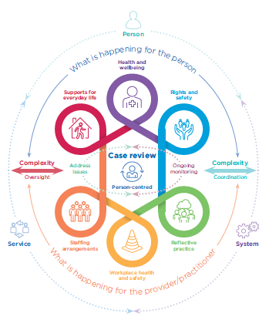
This is a diagram that depicts they key component for a case review (Meltzer, et al. 2018 p 7).

Theory
Following the guidelines and principals outlined in Doing an effective case review with a person with disability: A person-centred approach (Meltzer, et al. 2018) the following structures and key outlines below should be followed

Purpose of meeting:
- To address a key issue or a variety of issues
- To provide ongoing monitoring of a crisis situation or concern
- When a situation has reached crisis and further assistance is required
- To focus on the individual and bring all the stakeholders together for a collaborative approach to supports
- To get all stakeholders focusing on an individual goal or to work together to bring key focuses
When arranging these complex case meetings, it is highly important to have the purpose or aim of the meeting established prior to entering the meeting. The aims can be addressed in the invitation to the meeting and then re-established at the beginning of the meeting. This method can assist the person chairing the meeting to keep the meeting on track, allow structure and guidance to the meeting and to bring everyone together to focus on the individual being supported.

Who to invite:
People to consider inviting would include:
- The person: the person with the disability and/or their personal supports e.g. family, friends and personal representatives
- Providers: such as direct support workers, key works and support coordinator
- Managers: people in leadership roles in service provider organisations
- Practitioners: including, but not limited to, Behaviour Support Practitioners, allied health professionals, physicians and psychiatrist
- Other professionals: such as teachers, polices, justice, NDIS
Preparing for the review involves:
- Ensuring the relevant people are available to attend
- Preparing an agenda
- Send invites with location, time and aim of meeting
- If people are unable to attend – request a statement that could be presented at the meeting

Actions and Outcomes:
- At the end of each meeting, ensure all actions are noted, timeframes established and a person is allocated
- If an additional or follow up meeting is required, select the date and estimated time at the end of the complex case review meetings
- Minutes should be taken and disturbed to all invited to the meeting within a 48-hour period.

Tools and strategies
Meeting agenda: A dedicated time period should be allocated to get section and some sections may not be relevant pending the situation. Each agenda will be individualised to the person and their situation but could follow a similar structure of:
- Purpose of the meeting
- Introduction from the person or their key supports
- Review actions from past meetings
- Updates from all areas e.g. supports in everyday life, health and wellbeing, rights and safety, other professionals, work health and safety and any other reflective practices
- Other appropriate topics
- Action plan with timeframes and person responsible
Statements: gather statements from the person or other individuals if they are not able to attend the meetings
Meeting minutes: detailed overview of what was discussed at the meeting and Outcomes of actions from previous meetings
Meeting Actions & Outcomes: Actions from meetings with delegated person and timeline for action completion

Considerations for Practice:

Limited funded hours
Support Coordinators are expected to do so much in what can seem like so little time, and sometimes funding is limited. When allocating your time to tasks keep in mind how bringing a team together can decrease some of the load on a support coordinator.

Knowing your Mainstream Contacts
There are times complex case reviews will involve representative from mainstream services e.g. health, justice or Formal Guardian. It is important to know the appropriate person to contact and communicate with in these services.

Useful resources for Integrated Care team Review
- Agenda
- Meeting minutes and Action Plan
- Communication Plan

Participant Story:
The aim of the meeting is to identify an appropriate and consistent approach to holistically supporting David and reducing inappropriate presentations at the emergency room. In preparation of the Complex Case Review Jane creates an agenda and sends it out to the attendees. Jane also gathers a statement from David who does not want to attend the meeting. At the meeting the following are discussed and Janes nominates herself to take the minute:
- What is not working / What is working
- David’s statement
- What are the barriers to overcome? And how can we overcome them
- How to build service resilience
- Goals of each of provider
- Creation of communication lines and escalation pathways
- Contingency plans – if service breakdown occurs
- Creation of action plan and designation of actions to be completed

At completion of the meeting Jane summaries the meeting and the required actions moving forward, schedules the next meeting for 2 weeks and double checks she has all contacts correct email address to send the meeting minutes and action plan.

Supported Decision Making

Introduction
Supported decision making according to the United Nations Office of the High Commissioner for Human Rights is the “process whereby a person with a disability is enabled to make and communicate decisions with respect to personal or legal matters”. This process allows for a person with disability to have increased choice and control over their lives and have psychological benefits for instance, increased sense of self and quality of life.

Theory
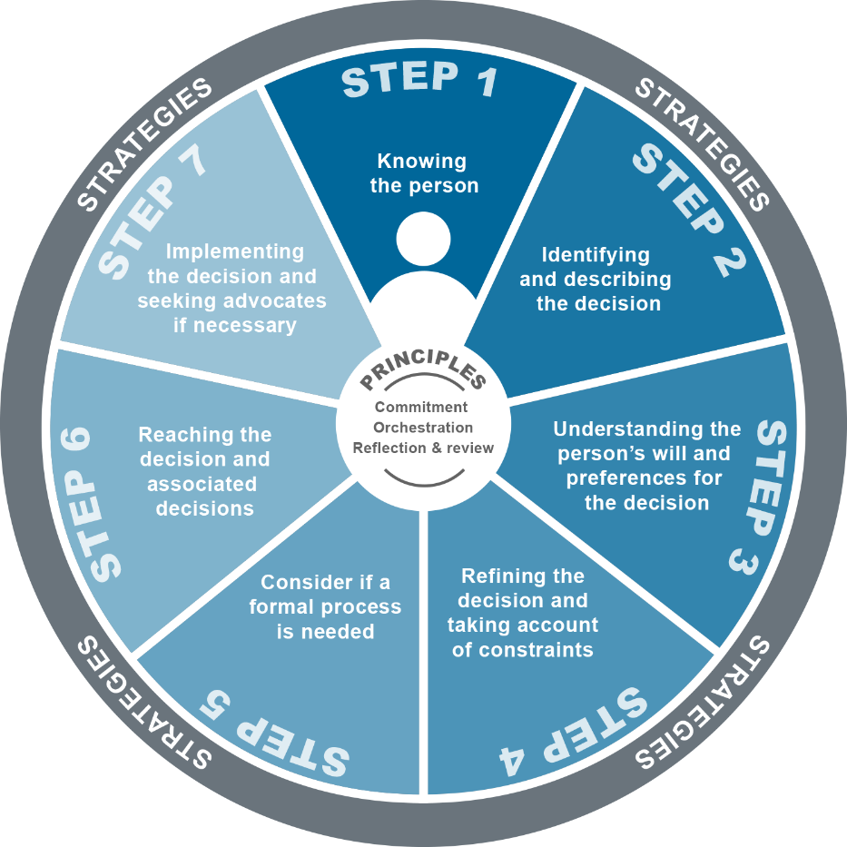
The supported decision-making framework puts the person with disability at the centre of their decisions, building on their strengths to increase their choice and control over their lives. The framework should be applied flexibly; as every person has different strengths and will require a varied level of support to make their decisions.

Bigby, C., Douglas, J., & Vassallo, S. (2019). The La Trobe Support for Decision Making Practice Framework. An online learning resource. Retrieved from: www.supportfordecisionmakingresource.com.au

If you are interested to read more about supported decision making frameworks please see below links.
- Latrobe Support Decision Making Framework
- NSW Public Guardian
- Supported Decision Making- Victorian Public Advocate
- DCJ- Supported Decision Making

Tools and strategies

Provide relevant information
- Provide the participant with all the information they require to make an informed decision in a balanced manner
- Describe risks and/or benefits and possible consequences
- Access specialist’s advice if required e.g. GP

Communicate in an appropriate way
- Understand how the participant communicates
- Provide information in preferred communication format e.g. AUSLAN interpreter, AAC device, visuals

Help the person feel at ease
- Be mindful of the environment
- Provide the participant with appropriate time to make the decision

Considerations for Practice:
Traditionally, persons with a disability have had others make important decisions on their behalf these are known as “Substitute” decision makers. Support decision making, there are two types of substitute decision makers Formal and Informal; Formal decision makers are appointed Guardians and or Administrators, and informal decision makers are commonly a family member.
You will come across some participants who have Guardianship and/or Administration in place, when this occurs it is important to involve the formal guardians in the appropriate discussions. It is important to know that guardians must consider the participants preferences.
Informal decision makers such as family members can enabling or disabling to the decision-making process; it is important that participants preferences are acknowledged and there is open discussion about the options available to the participant.
However, we need to acknowledge that the participant can make everyday decisions without the involving their formal substitute decision makers e.g. what they want to eat.

Participant Story:
David’s statement to the Case Review demonstrated that he does not like being supported by workers younger than him, as he feels they patronize him. During the review meeting the possibility of all of David’s support workers being older than him was discussed. The Community Support provider explained they had capacity to meet David’s request however the Accommodation service provider did not think they could meet the request.
As part of the action plan Jane was allocated the task of speaking to David about his Accommodation options. As per recommendations from engaged Occupation Therapist and Speech Pathologist; Jane uses visual aids to provide David with appropriate information about his current provides ability to change their staff to suit his requests. Jane then continues using visual aid to explain the other housing options available to David. Jane gives David a few days to make his decision. David decides that he wants to move to a new supported accommodation house with another provider.

Planning for Participants

Introduction
Planning for participants with complex support needs encompasses more than just NDIS based supports, contingency and crisis planning needs to be considered at all stages of the participant’s journey. In order to plan effectively we need to be aware of all aspects of the participants current supports, future support needs, and what mainstream supports and informal supports are available to the participant. Quality information gathering is vital in order to support the participant throughout the plan period, develop and implement contingency and crisis plans if required.
Consider those factors throughout the different stages of planning throughout the NDIS process:

First Plan:
This is the initial contact for the participant with the NDIS. At this stage, it is crucial that the information provided is comprehensive, up to date and outlines the complexities that your participant has. Diligence at this stage will ensure that the participant is set on an appropriate pathway to receive the support and expertise in planning they require due to their complexity.

Scheduled Plan Review:
This is the review that occurs at the end of a participant’s plan. For complex participants, it should be treated with the same attention to detail as a First Plan meeting. Information regarding incidents, changes in circumstances, or even ongoing complexities should be recorded in detail and accompanied by evidence and professional recommendations regarding safeguarding or supports to be established for the participant.

Review of a Reviewable Decision (s100):
This type of review can be initiated within the first 90 days after a participant’s NDIS plan has been approved. Generally, these reviews occur when the participant or their nominated supports disagree with decisions made by delegates in the construction of their NDIS plan. A list of ‘Reviewable Decisions’ can be found in the Operational Guidelines on the NDIS website.

Change of Circumstances (s48):
This type of review can be submitted at any time during the life of a participant’s plan and will need to be in response to a significant change in the participant’s circumstances that cannot be managed or addressed within the existing plan resources. Sufficient evidence is required to demonstrate the limitation of a current funding plan to support the participant appropriately in these circumstances.
When working with complex participants, unscheduled reviews (s100 or s48) may require more intensive supports to gather evidence, conduct contingency planning and address their support needs through alternative sources for an interim period of time while the review is conducted.
It's important to remember that the NDIA assesses priority of escalation through information that indicates:
- risk of harm to the health or well-being of a person;
- instability in the accommodation arrangements of a person, including the risk of homelessness;
- instability in the care arrangements of a person, including the risk of a primary carer not being able to provide care; and
- risk associated with the nature of the person's disability, including the risk of rapid deterioration or progression.
Consideration should be given to the involvement of an independent disability advocate (or specialist area advocate) to assist in supporting the participant through escalation processes. Noting that advocacy is not the role of the support coordinator and having someone experienced in the field may be very beneficial in achieving an appropriate outcome for the participant.

Theory
Planning meetings can be an anxiety provoking experience. The person-centred approach allows the participant to guide the development of their individualised support system. When using a person-centred approach, the participant/ family are seen as the experts in their own lives, the participant is viewed holistically, and their choices, desires, values, lifestyle are considered when developing the plan.

Tools and strategies

Planning for Complexity/Crisis
For participants with complex support needs or who have complex elements in their life it is important for the Support Coordinator to have a clear Action Plan for potential crises and how they will be managed if they arise (UNSW Being a planner with a person with disability and complex support needs (CSN): Planning resource).

Case Review:
Where multiple services or systems are involved, engagement on a regular basis, clear communication and collaboration between professionals is paramount to ensure that the participant has the opportunity to engage effectively with supports and work towards their goals.

Contingency Planning:
When a crisis does occur, having a clear understanding of what each support and system can offer the participant will assist in de-escalating and resolving the crisis situation for the participant.
Some key questions to assess efficacy the supports for participant with complex needs:
- What benefit does this support provide for the participant?
- Why does the participant require this type of support?
- How is this support delivered to the participant? Or How does the participant access this support?
- Are there any barriers or risks to the participant accessing this support?
- What are the safeguards that can be implemented so that the participant may access this support?
- Are there limitations to this support which may need to addressed through additional supports/resources?
- What are the ‘gaps’ in the participant’s support network?

COAG
Refer to COAG for responsibilities of different mainstream service systems. For further information please see Interagency Collaboration page 10

The Participant’s Voice
Participants should be encouraged to engage in the process of contingency planning as much as they can. This will look different for each participant; their ability to engage in the planning process may be impacted by their disability, support level, understanding of their needs, risks/safeguards and previous experiences. Therefore, some creative thinking may be required for maximum involvement from the participant.

Considerations for Practice:

Service Disagreement
Occasionally there maybe differences of opinion on planning approaches or assessments when working with complex participants. There needs to be open communication with participant, informal supports and service team to identify why there are differences and as a group work towards a solution.

Non-linear progression of crisis or contingency plans.
When crisis planning and contingency plans do not go as designed, the support coordinator needs to be flexible and solution focused to make appropriate adjustments as required. When events such as service disengagement, unforeseen events, changes in availability or changes informal supports, the plan must be adapted at short notice. Having a sound knowledge of participant’s community, informal supports and having a connection to the appropriate mainstream services (such as Justice, Health, Education) will all make plan adaption easier.

Participant Story:
Due to David’s decision to move into a new accommodation environment and the history of increased behaviours of concern Jane submits a change of circumstance and requests a plan review, due to a change in his disability support needs.
Jane uses appropriate NDIA language to identify that David is a risk to himself and others and risk of homelessness due to service disengagement as they cannot support him without a behaviour support plan. Additionally, Jane makes note that David would like to exercise his choice and control and move to a new Support Accommodation Provider.
Concurrently, Jane is continuing to contingency plan for David if a breakdown in supports occurs, and has scheduled the next Case Review for two weeks.

Participants who need Support to Engage

Introduction
Some Participants may require extra support to engage and maintain engagement. Failing to engage refers to situations where someone appears unwilling to engage or is opposed to service provision. Disengagement refers to participants starting to avoid or retracting from services, workers and/or organisations.

Theory
Rapport is the foundation of working relationships, however when working with disengaged and resistant participants building rapport can be difficult to create and maintain. Helen Spencer-Oatey (2000) created the Rapport Management framework; the framework looks at the management of harmony-disharmony among people. The framework centres on the ideas of “Face and Sociality rights”.
- Face: Positive social value
  - desire to be thought of positively in terms of personality traits (quality face)
  - desire for social identities/role to be acknowledged and upheld (identify face)
- Sociality rights: Fundamental personal/social entitlements
  - Right to received personal consideration and be treated fairly (equity rights)
  - Entitlement to associate or disassociated with other (association rights)
Face & Sociality Rights are concepts that support the creation and maintenance of positive rapport. When positive rapport is created and maintained we may not realise or analyse exactly how the working relationship has been created. However, if we are struggling to build/ maintain rapport we need to be mindful of how our attempts at rapport are being interpreted. Are we thinking of the person positively, acknowledging their social identity, treating them fairly, and allowing choice in interactions?

Tools and strategies
Developing Rapport with your participant is an important step in building a level of trust to work with participants who at risk of disengagement. Below is a list of suggestions to build and maintain rapport.

Active Listening
- Let the participant explain their story, have a person-centred approach acknowledging their experiences
- Have engaged body language e.g. nod occasionally;
- Seek to understand your participant and their circumstances, ask questions or paraphrase for clarification if you are unsure about anything;
If you are interested to read more about active listening please see below links:
- Active Listening-RACGP
- Reflective Listening- UNSW
- Active Listening: How to be a good listener

Communication
- Identify and explain your scope as a support coordinator, creating boundaries of what you can and cannot do within your role;
- Keep communication clear and simple; NDIS terminology can take bit to get used to so make sure to check in with your participant to see if they understand and clarify if required;
- Use alternate communication when required. E.g. visuals, ACC device, interpreter, easy English documents
- Give time for a response and allow for any questions they have;
- Regular check ins with your participant;
- Don’t be afraid to use the participants support network, for increased;
- Be responsive to the participant/ family when they reach out. This does not mean drop everything for them; rather respond to their inquiring in timely manner- even it’s just an acknowledgement of receiving the in inquiry.

Cultural Acknowledgement
- Understand that different cultures have different communication styles and a different style of rapport construction maybe required.
- If you are unsure about any cultural aspects, don’t be afraid to ask for clarification

General
- Be Predictable to provide a sense of safety. This builds the confidence of participant/ family to test assumptions and discuss sensitive or difficult issues
- Believing in each person's integrity and you are assured of other’s support and honest feedback. Listen and ask others to explain their reasoning and intent
- Become accountable and you can depend on each other to provide evidence,
keep good records and follow through with delegated actions.

Considerations for Practice:

Support Coordinator Burnout
Dealing with complex participants may also impact your emotionally wellbeing and can lead to ‘burnout’. To mitigate this risk, it is important to look after yourself and use positive coping strategies to maintain your resilience. Personal Toolkits involve individual coping strategies these vary from person to person; however, some ideas have been identified strategies are below.
- Supervision/ informal chats
- Physical Activity
- Pre-Planning
- Work/ Life Balance
- Doing activities, you enjoy

Service Disengagement / Ceasing Services
One of the barriers when working with disengaged and resistant participants is connecting and maintaining connection with service providers, especially if they tend to cancel their scheduled services. See Planning for Participants chapter for further information (contingency planning, care team meetings, COAG, the participant’s voice).

Initial engagement difficulties
Initial engagement with Participant’s can on occasions be difficult. When this scenario happens, it can put the support coordinator in the tough position; especially if they have pressures to meet billable hours and if their service is potentially declining participants who are willing to engage. Each provider will have different policies surrounding this scenario; however how a support coordinator needs to ensure they have attempted to engage the participant.

Intermittent Participant Disengagement
Due to various influences Participants can disengage from Support Coordination services intermittently throughout the plan period. When this occurs, a support coordinator should continue to try and engage the participant; this maybe a check in phone call or text. Alternatively, if the support system is actively collaborating, then using participants alternate supports to communicate or pass on messages can be beneficial and demonstrate to the participant that the support coordinator is still working to support the participant.

Negative perception of Support Coordinator
Some participants have a history of poor interactions with government systems and may hold negative perceptions towards support coordinators because the role can be misinterpreted as an employee of the NDIA. If this occurs it is important to explain your role; and how as a support coordinator your job is to help participants implement their plan and work towards their goals.
Providing Service Without a Signed Service Agreement
As best practice a Service agreement should be in place however, there are times when this is difficult to achieve. The question is, can a plan be charged without a signed service agreement? Especially when the support coordinator is taking time to try and engage the with the participant and work to implement the NDIS plan. This is grey area within the scheme and should be best discussed with your management team and the NDIA planner or LAC.

Participant Story
It has been two weeks since Jane sat down with David to support him to make a decision about his accommodation. Jane has heard back from the NDIA and they are going to conduct a plan review, however Jane has not been able to communicate this with David to arrange a time and date for the meeting. Jane brings up David’s disengagement from Support Coordination services at the Case review meeting; Community Access provider explains that David has told staff he is “annoyed at Jane” because “she is taking too long”. Jane asks the service provider to communicate with David about the plan review, and to contact her if they have any questions.

Intersectionality and Cohorts

What is Intersectionality?
Intersectionality focusses on how interactions of and between race, class, gender, and other social and political experiences create an overlapping and interdependent system of disadvantage (Crichton-Hill, 2013). When supporting participants adhering to the following principals can be advantageous:
- Person centred Practice: Putting the person experience at the centre of our practice
- The Participant is the expert in their experience: A participant’s truth is important in understanding their experiences and building rapport.
- Solutions focused: work collaboratively to create achievable goals and create steps to achieve
- Rights Based Practice: Understand all relevant right

In this Chapter we will cover the following cohorts:
- Aboriginal and Torres Strait Islander people
- LGBTIQA+ Participants
- Cultural and Linguistically Diverse Participant’s
- Working with Participant’s with Complex Trauma Background
- Psychosocial Disability and Mental Health:

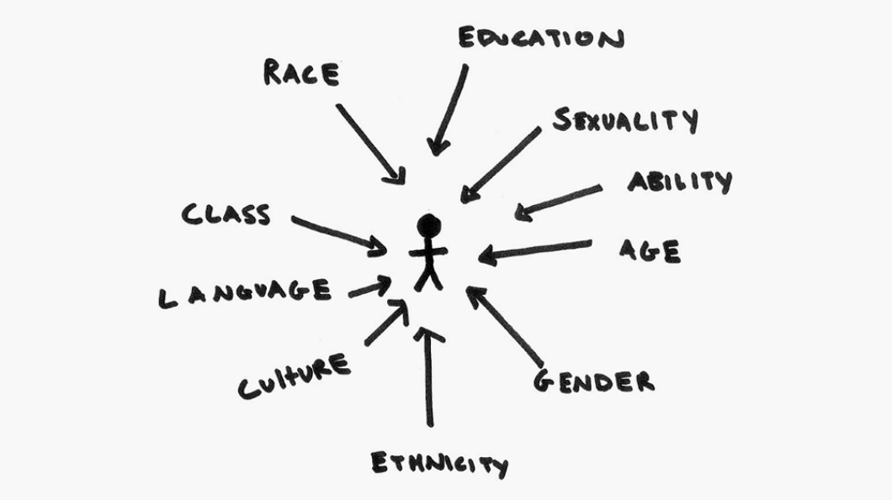
Retrieved: What does intersectional feminism actually mean? https://iwda.org.au/what-does-intersectional-feminism-actually-mean/16/06/20.

Aboriginal and Torres Strait Islander Participants
Introduction
At some stage you may work with participants who are of Aboriginal or Torres Strait Islander descent. It is important to remember that asking for assistance is not often sought, family take care of family in this culture, you must be patient and don’t rush into referring the participant to support services, this may take a bit of time to build a rapport.
Theory
Generally speaking, Aboriginal and Torres Strait Islander people have a different perspective on disability and how they access supports; understanding the cultural differences and how social conditions can influence motivation is a key. There are two basic types of motivation; intrinsic and extrinsic. As a rule of thumb intrinsic motivation is more self-determined then extrinsic motivation as seen on the continuum below. A combination of knowledge of culture and utilising self-determination theory approaches can increase beneficial engagement with Aboriginal and Torres Strait Islander community.

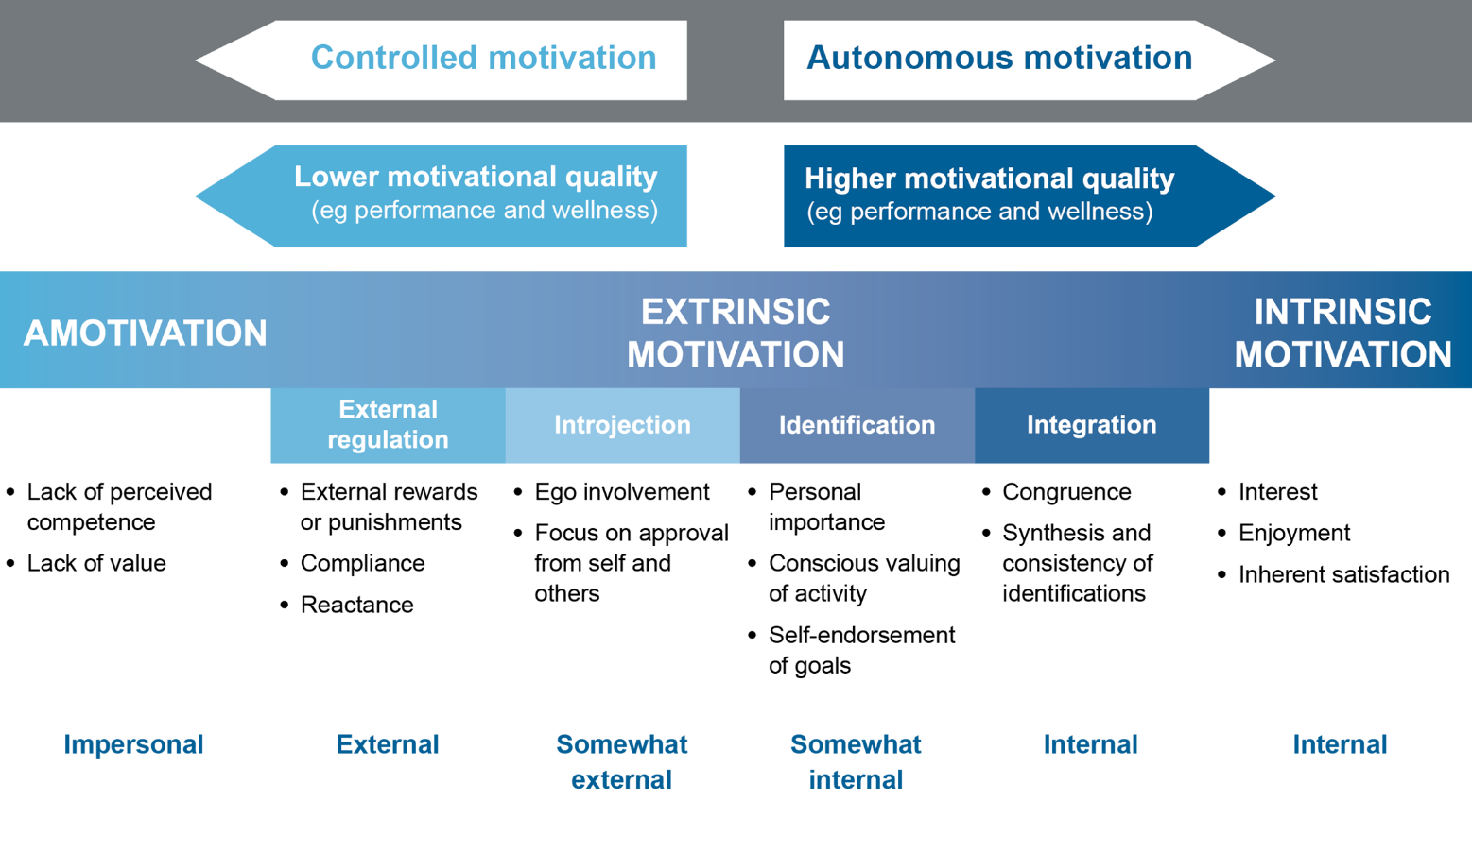
Based on Ryan, R.M. & Deci, E.L.(2000). Self Determination Theory and the Facilitation of Intrinsic Motivation, Social development and Well-Being. Adapted from https://twitter.com/centerforsdt/status/935914261746016256

Tools and strategies
When working with participants of Aboriginal and Torres Strait Islander descent it is important to understand the following as these can assist practitioners to recognise their personal attitudes and prejudice in a clinical context and provide a framework of engagement:
Cultural Awareness: The first step towards understanding the different culture of Aboriginal and Torres Strait Islander people
Cultural Sensitivity: The acceptance that there are legitimate differences in the experience and realities of people of Aboriginal and Torres Strait Islander decent
Cultural Safety: means “actions to protect from danger and/or risk to participants/ community from hazards to health and wellbeing”. The focus is on interactions and the power relations between the clinicians and the participant, achieving a partnership where the power is shared between the two individual’s and cultural groups involved.
Cultural Competence: Focuses on the capacity of the System to improve the health and wellbeing by integrating culture into service delivery. It’s the combination of attitude, knowledge, skills and policy coming together to enable effective cross-cultural practice.
Self- determination theory: Is a theory of human motivation. It focusses on the impact of social and cultural factors that can facilitate or hinder people’s willingness and capability to self-motivate and increase autonomy. The main components are summaries below:
- Autonomy: feelings of control of their own behaviours and goals; does not mean to be independent of others.
- Competence: the skills needed for success
- Relatedness: a sense of belonging and attachment
https://selfdeterminationtheory.org/theory/
If you are interested to read more about working with Aboriginal & Torres Islanders people please see below links.
- Patient Centred Care with case study
- Patient Centred Care- Cultural Safety
- Working with Aboriginal People and Communities
- Closing the Gap - Implementation Plan
Resource and links:
South Australian Aboriginal Services Directory.
Catalyst Foundation in partnership with Turkindi Inc. Provides up-to-date listings of Aboriginal Organisations, Aboriginal Businesses and non-Aboriginal Organisations and businesses providing social and community services to Aboriginal people. Aboriginal Services Directory

Considerations for Practice:

Perception of NDIS
Due to the different perception of disability within the Aboriginal and Torres Strait Islander culture, implementing an NDIS Plan may be difficult. The different perception of the NDIS and its ability to support indigenous participants may be limited or not culturally encouraged. In the support coordination role, it is important to understand the motivation for either accessing specific supports or not wanting to access supports at all and through increased understanding you may be able to influence connection to appropriate services.

Services Limited understanding of Aboriginal and Torres Strait Islander culture
Not all service providers understand Aboriginal and Torres Strait Islander culture, and this can be barrier to accessing and maintaining ongoing supports. When implementing services, it is important to identify the services that have this cultural understanding, as this can increase the likelihood of continuity of supports.

LGBTIQA+ Participants
Introduction
People often overlook gender identities and sexual orientations when it comes to people with disability. This might be because other disability-related concerns are usually prioritised over a person’s gender identities and sexual experiences. People with disability and people who are neurodivergent (e.g. ASD diagnosis) are often viewed as being asexual or non-sexual. In other cases, it is often assumed that gender identities and sexual preferences are not significant or relevant to a person’s support needs falsely based on them having intellectual impairments. These assumptions are not true and this issue of invisibility is further exacerbated in crisis situations.
This section aims to provide introductory information about LGBTIQA+ people and related issues so that Support Coordinators can better understand and feel more confident in supporting LGBTIQA+ people with disability.
Theory

Foundational knowledge of sex, gender and sexuality
To appreciate diversity, it is important to firstly understand that biological sex, gender identity, gender expression and sexual orientation are separate aspects of a person’s identity and experience. Refer to the below Genderbread Person for an illustration.
The Genderbread Person helps visually differentiate the four mentioned aspects, showing how a person can have varying experiences on a range of spectrums that are not mutually exclusive.
It is important to keep in mind that because gender identity and sexual orientation are separate aspects of a person, one aspect cannot be used to assume/determine the other.
If you are interested to read more about working with LGBTIQA+ community please see below links.
- A Comprehensive Glossary
- Gender and Sexuality video
- Trans 101- The Basics
- What "Non- Binary" means to me video
- You can't ask that- What is Intersex?
- What it's like to be intersex video
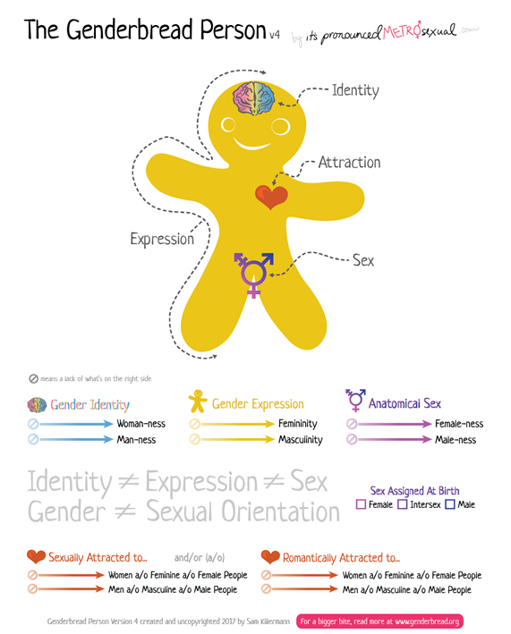
Tools and strategies
It is worth noting that the most important things you can do to support someone who is LGBTIQA+ is to:
- Appreciate diversity -not everyone is the same and it’s okay to be different;
- Respect the person – it is okay to disagree but it is not okay to disrespect another;
- Ask, don’t assume – if you are unsure of anything, it is better to respectfully ask the person instead of assuming.
- Help ensure that the person feels safe and is safe in their home and in the community.
Further resources:
- QLife
- Genders, bodies and Relationship Passport
- NDIA's LGBTIQA+ Strategy
- LGBTIQ+ Inclusive Practice Guide for Homelessness and Housing
- LGBTIQA+ Directory
- National LGBTI Health Alliance
- A gender Agenda- Resources
- Trans Pathways
- Trans Pathway - Summary
Consideration for Practice:

Reflective practice and keeping professional boundaries
Managing our own reactions and attitudes towards another person who identifies as LGBTIQA+ can be challenging if we are not familiar with working with the LGBTIQA+ community.
- Step back and reflect on the situation before further action that can potentially lead to harmful consequences.
- Remember that as a Support Coordinator, while it is important to understand the participant’s experience of diversity in order to connect them to the appropriate services, dealing with whether their identities and experiences are right or wrong is not within your scope.
- Have a safe space to reflect on your personal beliefs and your practice while fostering respect regardless of belief.
- Access support from supervisors, peers or from the relevant agencies who are experienced in working with LGBTIQA+ communities such as QLife.

LGBTIQA+ People with Disability
Being sexually and gender diverse and having a disability are not mutually exclusive.
- Queer and Disabled Pt.1 . Misconceptions
- Trans 101: Neurodiversity video
- The Full Spectrum: What's it's like to be gay and autistic?
Knowing and understanding a person’s preferences can help promote better outcomes. For example, a person may feel more comfortable working with support workers, professionals and hospital staff of a specific gender. Having this need met can make a difference in helping them feel safe and therefore calm when accessing these services, reducing the likelihood of disengagement from services, behavioural escalation or the need for flight-or-fight responses in crisis situations.
Respecting the person’s identity and their preferences is one of the important steps in respecting and protecting their rights, which ultimately helps improve and maintain their quality of life.

Cultural and Linguistically Diverse (CALD) participants (including those with migrant/refugee background/history)
Introduction
Cultural and linguistic diversity can add to complexity as it can be associated with challenges in accessing/engaging with services, getting appropriate assessment, intervention, implementation and collaboration. This can be due to language barriers, differences in cultural beliefs/norms, and the lack of suitable services available. Funding limitations can also impact service providers’ ability and flexibility to accommodate for diversity-related needs.
This section aims to provide relevant information so that Support Coordinators can better understand and feel more confident in supporting people with CALD backgrounds.
Theory
“Australia is a nation of peoples with many languages, ethnic backgrounds, traditions and religions where:
- more than a quarter of Australians (26 per cent) were born overseas.
- more than 300 different languages are spoken by people from culturally and linguistically diverse (CALD) backgrounds in addition to the hundreds of languages spoken by Aboriginal and Torres Strait Islander peoples.
- Australians identify with around 300 different ancestries”
Source: Australian Bureau of Statistics, 2016 Census, NDIA Cultural and Linguistic Diversity Strategy 2018
Cultural factors can bring about differences in family dynamics, parenting styles, personal beliefs, expectations and attitudes towards disability. These can affect progress and outcomes in both positive or negative ways.
Cultural differences can also bring about conflicting views and resolutions that challenge progress and outcome, particularly when the participant’s guardian/decision maker/parent requires extra support to support the participant.
Tools and strategies
- Language interpreting services for providers – TIS National
- NDIA Cultural and Linguistic Diversity Strategy 2018
- Individualism/ Collectivism.
- Disability Support Guide- Multicultural Services
- Multicultural Services Directory
- Engaging CALD communities in the NDIS (for information and recommendations related to: Cultural Barriers to CALD Engagement with Disability Services; NDIS Systemic Limitations for CALD Communities; Strategies for Engaging CALD Clients; Culturally Appropriate Service Delivery and Preferences; Building Organisational Capacity)
- National Ethnic Disability Alliance National Ethnic Disability Alliance
- Transcultural Mental Health is a state-wide unit which supports area mental health and psychiatric disability support services in working with culturally and linguistically diverse (CALD) consumers and carers throughout each state – you can Google search “Transcultural Mental Health” along with your state’s name to find further information specific to your state.

Consideration for Practice:

Dealing with marked differences
Different cultures may have different views and values around disability and sometimes this can be conflicting with the Australian views, values and legislations. Sometimes, these differences can be perceived as extreme. Some cultural groups may find it difficult to prioritise the rights, quality of life and wellbeing of the person with disability, for various reasons. It would be helpful to be aware of these differences if they are present, as these can illicit difficult emotions such as shock, anger or frustration. Debriefing or consultation with a peer, supervisor or manager can be helpful in these situations.

Reflective practice and working with different strengths
Sometimes, you may find yourself doing all you can and yet making little progress with participants from CALD backgrounds. It may be helpful to:
- Reflect on what you think might be the barriers and whether these barriers are related to the participant’s CALD background. If identified, it may be worth exploring alternative/out of the box solutions/options that may be more suitable to the participant’s and their family’s specific needs.
- Approaches that are strength-based are more likely to be effective, especially in circumstances where deficits and problems may have been the focus. Sometimes, differences can be strength, too.

Working with Participants with a Complex Trauma Background

Introduction
The prevalence of complex trauma backgrounds in participants with multiple and complex support needs is a recurring theme that appears to be often overlooked.
Often (and quite rightly) we associated complex trauma with childhood trauma. Where we are working with participants who are currently in or have exited statutory out of home care systems this is more easily defined and recognised. However, when working with older participants where their trauma background may not be as easily determined and multiple co-morbidities exist, consideration of exploring whether the participant has experienced significant trauma over the course of their lives may be worth building into your practice, as this can determine the type of service and skillset of workers that is required to meet the needs of the participant.

Theory
The following, taken from the Berry Street publication Taking Time: A trauma-informed framework for supporting people with intellectual disability summarises complex trauma well.
“.....key features of complex trauma include a more complex and tenacious set of symptoms, major personality changes and greater vulnerability to further harm, such as when self-inflicted and/or as a result of the behaviours of others. It is not a formal mental health diagnosis. Complex trauma is usually a result of cumulative, repetitive and interpersonal assaults. It is particularly pernicious if it occurs in childhood and where the source of trauma is a person who has a caregiving and trusting relationship, and is meant to be a source of safety....”
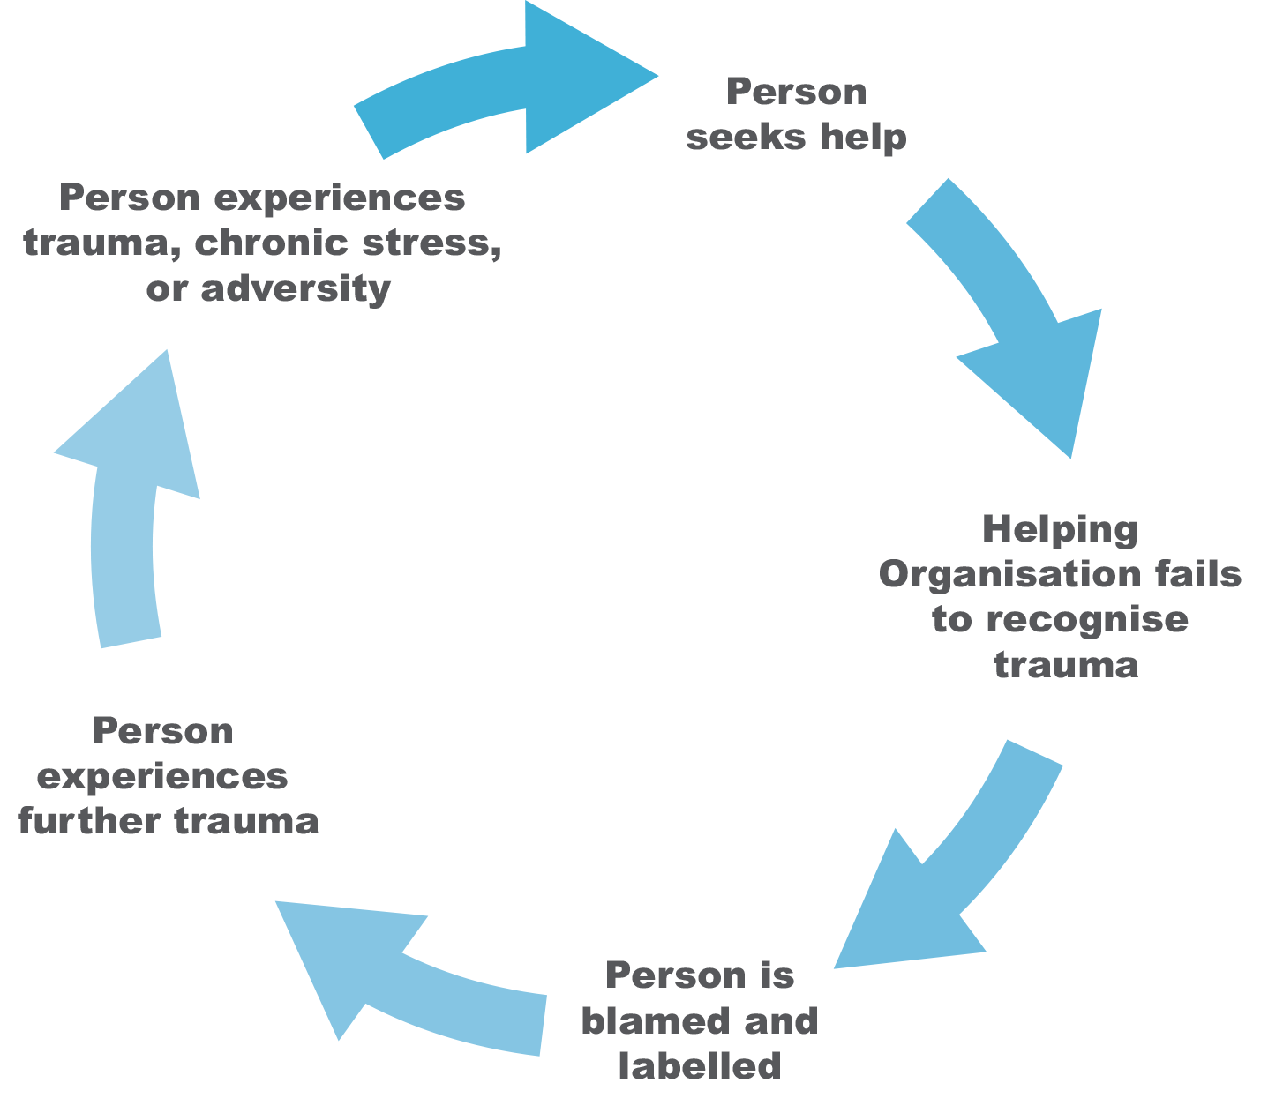

Jackson, A. L., & Waters, S. E. (2015). Taking Time – Framework: A trauma-informed framework for supporting people with intellectual disability. Melbourne, Australia: Berry Street.

Tools and strategies
When working with participants with complex trauma backgrounds there are a number of key principles to ensure that the participants emotional, physical, social and cultural needs are able to be met. Of particular note is that the underpinning principle, where all other principles and the success of trauma-informed practice is contingent on, is the safety of the participant. The 5 key principles are:
- Safety - Safety is the key principle on which all others depend. This includes ensuring the physical, psychological, social, moral and cultural safety of the participant is met.
- Trustworthiness – This is about getting to know and understand the person being supported. The practitioner must maximize trustworthiness through relationships, task clarity, consistency and interpersonal boundaries as well as assisting people to develop and maintain strong and therapeutic support networks
- Choice – This relates to empowering the participant to make their own choices and have control over their lives whilst at the same time maintaining their safety. This might include choices as simple as what their want to wear, through to what level of support they want or the kinds of risks they want to take.
- Collaboration - Seeking ways to collaborate with the person being supported and their extended support network. This may include family, friends, support providers, formal decision makers and advocates.
- Empowerment – Through person centred practice, ensure the person’s voice is being heard and heeded. For people who do not use language to communicate, we must support their method of communication to ensure they are being empowered to have their voice heard.
National Disability Services (NDS) have developed a series of short Trauma Informed Support films These films aim to assist support workers, providers, people with disability and their families to understand what trauma is, the impact it can have, and ways in which everyone in an organisation can provide trauma-informed support. The topics include:
  - Understanding Trauma
  - What is Trauma Informed Support?
  - A Trauma Informed approach to Positive Behaviour Support
  - How can Organisations Embed a Trauma Informed Approach?
  - Building networks of support and recognising vicarious trauma
The above short films are available at: https://www.nds.org.au/item/considering-additional-risk
The Blue Knot Foundation is the National Centre of Excellence for Complex Trauma. They have developed various resources for practitioners in regards to Trauma Informed Practice. Suggested resources include:
  - Trauma Informed Practice: Blue Knot Foundation Factsheet for Workers in Diverse Service Settings. Available at: https://www.blueknot.org.au/Resources/Fact-Sheets/WorkersFact-Sheet
  - Practice Guidelines for Treatment of Complex Trauma and Trauma Informed Care and Service Delivery (2019). Available at: https://www.blueknot.org.au/resources/Publications/PracticeGuidelines
  - Trauma and the Law: Applying Trauma-informed Practice to Legal and Judicial Contexts. Available at: https://www.blueknot.org.au/ABOUT-US/OurDocuments/Publications/Trauma-Law

Orygen is an organisation that focuses on youth mental health issues. They have developed the following resources specific to trauma informed care:
- What is trauma-informed care and how can I help implement it in my organisation? Available at: https://www.orygen.org.au/Training/Resources/Trauma/Toolkits/What-istrauma-informed-care-and-how-can-I-help-i/Trauma-informed-caretoolkit?ext=
- Trauma informed care: Working with Refugees and Asylum Seekers Webinar. Available at: https://www.orygen.org.au/Training/Resources/Trauma/Webinars/refugees-asylum-seekers
Berry Street developed the Taking Time Trauma-Informed Framework to guide service providers who support people with intellectual disability, which we have referenced earlier in this section:
- Taking Time Framework: A trauma-informed framework for supporting people with intellectual disability. Available at: https://learning.berrystreet.org.au/sites/default/files/2018- 05/Taking-Time-Framework.pdf

Consideration for Practice

Influencing Mainstream and Disability Service Systems to Understand the Impact of Trauma
Despite trauma informed practice not being a new concept and the long term impact of trauma being widely recognised across most professions, it is often difficult to influence stakeholders to recognise trauma as part of a persons interactions with their service. Often a person who has experienced significant trauma and has subsequent behavioural or other anti-social issues, is labelled as difficult and is blamed for those behaviours which then perpetuates ongoing trauma, which in turn worsens the situation.
If trauma is identified or suspected as being a causal factor in the complexities of a participant, as part of any engagement with multiple stakeholders, this should be discussed in length and strategies (aligned with the basic trauma informed principles) developed in conjunction with the participant to ensure service interactions, engagement and support provision is as successful as possible.

Vicarious Trauma (VT)
As practitioners we always focus on empathetic engagement. However, due to the risk of being exposed on a regular basis to traumatic material related to one or multiple participants, this can at times lead to what is known as vicarious trauma. Vicarious trauma is a normal reaction to exposure to trauma material in the same way that PTSD may manifest itself for people who directly experience a traumatic event.
Experiencing VT and the effects of this can be as debilitating as burnout, and can significantly affect our ability to self-manage ongoing exposure to trauma material and stress which is often unavoidable when working with complex participants.
To manage the effects of VT, a strong awareness of the emotional, behavioural, physiological and other symptoms associated with VT is essential, with good self-care strategies, supervision and training needing to be in place to mitigate the risk of VT impacting seriously on practitioners mental health.

Psychosocial Disability and Mental Health

Introduction
At some stage you may begin working with a participant with psychosocial and/or mental health disabilities. It is important to remember that ‘one size does not fit all’ and each participant is unique.

Theory
A person-centred approach is a widely used and well researched strategy for working with people with disability. This technique places the participant at the centre of their own life decisions, service planning and delivery.

Tools and strategies
A recovery orientated approach can be used to guide your conversation with participant; the principals of recovery orientated mental health practice are;
- Uniqueness of the individual: Recovery is personal and goes beyond health to include social inclusion and quality of life, empowering the individual to recognise that they are at the centre of care they receive.
- Real choice: support and empowers individuals to make their own choices about how they want to lead their lives and works to ensure there is a balance between duty of care and dignity of risk.
- Attitudes and Rights: Promoting and protecting the persons individual rights, and supporting the person to maintain and develop social, recreational, occupational and vocational actives which are meaningful to them.
- Dignity and Respect: Being courteous respectful, and honest in all interactions. Involves respecting the individual and their values, beliefs, and culture; and challenging discrimination wherever it exists.
- Partnership and Communication: Acknowledges that each individual is the expert in their own life and recovery involves working together to provide support that makes sense to the individual. There is an emphasis on open communication sharing relevant information in a clear manner to support the person to realise their own goals and aspirations.
- Evaluating Recovery: Individuals and their carers track their own recovery through looking at their life holistically, including: Housing, employment, education, social and family relationships, health and well-being. Services can use the individual experiences to make quality improvements to their support.
If you are interested to read more about active listening please see below links:
- Reimagine- Mental Health, Recovery and the NDIS
- Recovery Orientated Language Guide
- Mind Australia- Promoting Psychosocial Functioning and Recovery

Considerations for Practice:

Nature of Psychosocial Disability
Psychosocial Disability can be episodic in nature; meaning that there will be times participants require a higher level of support then usual; frequency and length of episodes will be variable. It is important in your role to understand the nature of the participants disability; as this will help you understand how and when your participant may need additional supports and to check in regularly.

Reflective Practice
In general, reflective practice is helpful. Taking a step back and reflecting on the situation before further action can mitigate potentially harmful consequences. Remember that as a Support Coordinator, while it is important to understand the participant’s experience in order to connect them to support them appropriately; intervention is not in your scope.

Support Coordination Scope
Sometimes you may find yourself being pushed out of your scope as a support coordinator towards a clinical support space. It is important to remember your role within a wider support system for your participant. If maybe helpful to:
- Communicate with the wider team to identify a strategy to appropriately redirect the participant to the correct clinical supports, while maintaining a positive working relationship
- Clearly identify the scope of your role to the participant and remind them if required. You say something along the lines “I am unable to provide that service; however, I can do ______”

Accessing Subject Matter Expertise

Introduction
Support Coordinators are likely to be working with participants from a wide range of cohorts and Support Coordinators themselves come from a range of background with various experiences so seeking out subject matter expertise (SME) is context dependent. Drawing on SME will enable the delivery of a higher quality service that better meets the needs of the individual participant and their supports.

Theory
SME is defined as a subject-matter expert who is in authority of a particular area or topic (Wikipedia). For support coordinators who are expected to connect participants to services and navigate multiple systems often simultaneously, accessing SME can be beneficial role development. By accessing SME a support coordinator is working on increasing their understanding and developing their capability to guide participants through the various systems and supports available.

Tools and Strategies

Accessing SME is not about handing over a problem to someone else, but rather about bringing in new knowledge to enable to you to be in a better position to resolve and/or navigate the system yourself. A key to accessing SME is to consider Who, Why, What, When, How:

Who is SME?
SME are persons/organisations throughout the sectors who have extensive knowledge and experience in a specific area. Using your local network to identify SME’s is a good place to start your search, additionally at the end of this chapter there is a list of links to established services of that can be a starting point for accessing SME.

Why access SME
Before seeking SME it’s important to understand your reasons; some examples are listed below but the list is not exclusive:
- Seeking a new direction
- Mitigate against a current or future risk
- Confirmation of current direction
- Assistance supporting in unscheduled plan reviews
- How to manage complexity
Through understanding your reasons for accessing additional supports you will be in a better position to guide the SME to providing the appropriate information for your needs. Additionally, having a clear reason will allow you to adapt the information to your participants circumstances.

What is needed to access SME
Accessing SME is about increasing your capacity, so it is important to have a baseline understanding about the SME you are wanting to access. Having this baseline understanding will enable you to get the most out the SME as the expert will be able to build on your established knowledge. When building your knowledge use reputable sources such as the COAG, NDIS Act, the NDIS Quality and Safeguards Commission frameworks or other service Acts.

How to access SME
SME comes in various forms; so, it is important to be aware of the different formats available to access. SME can be as simple as speaking to a team member who has experience in the area you need- this can be either informally or in a team meeting. More formal formats of SME can be access through Communities of Practice (CoP), external organizations providing specific training or consultancy programs. It is important to recognize what format of SME is available as some are available online and/or face to face; when identifying what is best for you reflect on how you best absorb information and try to match the SME to this format when possible.

When should you access SME
Accessing SME is not going to fix a problem or stop a crisis; however, SME support may help to navigate complexity, crisis situations and support contingency planning. Therefore, it is important to access SME pre-crisis and or when risks areas identified.

Considerations for Practice
Time Poor
Support Coordinators have reported that they are time poor and have high billing requirements, so it is understandable why it is difficult to justify why accessing SME is a good use of time. Keep in mind that SME is about building your capabilities in the support coordination role and accessing SME now could save your time in the future.
Unable to find a starting point
Sometimes you just don’t know where to start because of the complexity. Accessing SME may be beneficial in this scenario, as they have the ability to look at the complexity from a different perspective and can help clarify direction. For this to be beneficial you will have to be prepared to reflect on your current practice and look at your own skills
Application of SME
The SME may be able to provide you with direction and theories to support your work, however remember the SME will not have the background knowledge you do. When this occurs, you will have to bridge the gap from theory to practice. The application will differ from participant to participant so it is beneficial to be flexible in your approach
Remote & Rural
Remote and rural support coordinators may have increased access to SME due to online formats, however implementing SME recommendations in these areas may come across additional barriers. Rural and Remote support coordinator will have to be extra flexible and innovative in their approach to application. Keep in mind there may be SME for specific rural and remote regions available.

Resource Links
The links below are starting points in accessing SME across disability and mainstream interfaces in NSW, ACT and SA
State Based Services
Health | ACT | Health & Disability
 | NSW | Health & Disability
 | SA | Health & Disability
Education | ACT | Students with Disability
 | NSW | Learning Strategy
 | SA | Supporting Student with Disability and Special Needs
Community Services | ACT | Disability Strategy
 | NSW | Disability Inclusion
 | SA | Child Protection, Child Protection and the NDIS
Housing | ACT | Housing ACT , Argyle Housing
 | NSW | Disability Council, , Homes Out West , Argyle Housing, Link Housing
 | SA | Disability Housing, Community Housing , Public and Community Housing
Justice | ACT | Disability Justice Strategy,
 | NSW | Justice and Disability, legal aid
 | SA | Disability Justice Plan ,
Public Guardian & Trustee | ACT | Public Trustee and Guardian
 | NSW | Public Guardian
 | SA | Public Trustee

National services
Aboriginal and Torres Strait Islander | AbSec
 | Australian Indigenous Health Info Net
 | Department of Social Services Resources List
 | First Peoples Disability Network Australia
 | Kurranulla Aboriginal Corporation
 | NACCHO
 | NDIS- Aboriginal and Torres Strait Islander Strategy

Carers | Carers Australia
 | GriefLine
 | One Door
 | Carers Gateway

Children and Parents | Department of Social Services Early Intervention
 | KidsHelpline
 | Disability and Parenting Supports
 | Raising Children (ASD)
 | Telephone Counselling Services

Financial | National Debt Line
 | Services Australia- Managing Debt
Domestic Violence | 1800respect
 | LifeLine Domestic Violence

LGBTQI+ | Autism Spectrum Australia- LGBTQI+
 | National LGBTI Health Alliance
 | Openminds
 | Qlife

Mental Health | BeyondBlue
 | Black Dog Institute
 | Embrace Mental Health
 | Reimagine
 | Promoting Psychosocial Functioning and Recovery
 | Headspace
 | Head to Health
 | One Door Mental Health
 | Project Air- A Personality Disorders Strategy
 | Indigo Daya - Psychosoical Recovery Blog

NDIS Specific
Support Coordination | COAG – Council of Australian Governments Agreement of scope of mainstream services and the NDIS
NDIS Price Guide - please be aware this may not be up to date
Modified Monash Model
NDIS Operational guidelines
Administrative Appeals Tribunal (AAT)

Housing | Summer Foundation  Housing Hub  Young Care
Disability Related Health supports | Disability Related Health Supports
Quality and Safeguard Commission | NDIS Quality and Safeguard Commission  Positive Behaviour Support  NDIS Provider Register and Compliance and Enforcement Actions
AT & Home Mods | Home Modification Explained  Assistive Technology Explained
LAC/ ECEI Providers | Offices and Contacts in your area

Advocacy | Regional Disability Advocacy Service
 | Disability Services Australia - Advocacy Resources
 | My Forever Family - Foster Care Advocacy
 | Justice Advocacy Service - NSW
 | Disability Rights Advocacy Service

Alcohol and Other Drugs | Reach Out
 | Network of Alcohol and Other Drug Agencies
 | Alcohol and Drug Foundation

Employment | Services Australia - DES
 | Disability Employment Australia
 | NDS- employment

Aged Care | My Aged Care
 | Younger People Residential Aged Care (YIPRAC)
 | Summer Foundation- NDIA Aged Care Fees

References

Australian Bureau of Statistics, 2016 Census, NDIA Cultural and Linguistic Diversity Strategy 2018
AGA. Supporting Intersex, Trans & Gender Diverse people [Internet]. AGA; [cited 2020 Sep 24]. Available from: https://genderrights.org.au/
Berry Street. (2020, August 25). https://www.berrystreet.org.au
Bigby, C., Douglas, J., & Vassallo, S. (2019). The La Trobe Support for Decision Making Practice Framework. An online learning resource. Retrieved from: www.supportfordecisionmakingresource.com.au
Blue knot Foundation helps childhood trauma survivors. (n.d.). Supporting adult survivors of childhood trauma & abuse. https://www.blueknot.org.au/ABOUT-US/OurDocuments/Publications/Trauma-Law
Booklets and factsheets [Internet]. Geelong: NDIS; 2020 Sep 9 [cited 2020 May 1]. Available from: https://www.ndis.gov.au/about-us/publications/booklets-and-factsheets
Collings S, Dew A, Dowse L. Being a planner with a person with disability and complex support needs: Planning resource kit [Internet]. Sydney: University of New South Wales; 2015 [cited 2020 Sep 23]. 72 p. Available from: https://www.arts.unsw.edu.au/sites/default/files/documents/IDBS_SPF_ResourceKIt.pdf
Communities & Justice. Doing an effective case review with a person with disability [Internet]. New South Wales Government; 2019 Sep 24 [cited 2020 Sep 23]. Available from: https://www.facs.nsw.gov.au/download?file=630361
Complex trauma and trauma-informed practice guidelines. (n.d.). Supporting adult survivors of childhood trauma & abuse. https://www.blueknot.org.au/resources/Publications/PracticeGuideline
Considering additional risks. (n.d.). National Disability Services. https://www.nds.org.au/item/considering-additional-risk
Culturally speaking: Managing Rapport through talk across cultures. (2000). Google Books. https://books.google.com.au/books?hl=en&lr=&id=AhkjPIhKUxEC&oi=fnd&pg=PA11&ots=Nilg-SbEyP&sig=dX3lvXyuD33gGVu7F8fFQLuDVyM&redir_esc=y#v=onepage&q&f=false
Department of Community Services. Working With Aboriginal People and Communities [Internet]. New South Wales Government; 2009 Feb [cited 2020 Sep 21]. Available from: http://www.community.nsw.gov.au/__data/assets/pdf_file/0017/321308/working_with_aboriginal.pdf

Department of Health. Principles of recovery oriented mental health practice [Internet]. Australian Government; 2010 [cited 2020 Sep 23]. Available from: https://www1.health.gov.au/internet/publications/publishing.nsf/Content/mental-pubs-i-nongov-toc~mental-pubs-i-nongov-pri
Fact sheets for survivors, supporters, workers, GPs. (n.d.). Supporting adult survivors of childhood trauma & abuse. https://www.blueknot.org.au/Resources/Fact-Sheets/WorkersFact-Sheet
Federal Financial Relations. National Partnership Agreement on Closing the Gap in Indigenous Health Outcomes: Implementation Plan. Jurisdiction: New South Wales [Internet]. Federal Financial Relations; [cited 2020 Sep 21]. Available from: http://www.federalfinancialrelations.gov.au/content/npa/health/_archive/ctg-health-outcomes/NSW_IP.pdf
Genders, bodies and relationships passport. (n.d.). LGBTIQ+ Health Australia. https://www.lgbtiqhealth.org.au/passport/
Gender and Sexaulity Animation [Video]. (2017, September). YouTube. https://www.youtube.com/watch?app=desktop&v=mtYuUL3OdUY&feature=youtu.be
Glossary. (2019, September 20). A Gender Agenda. https://genderrights.org.au/resources/glossary/
How the planning process works [Internet]. Geelong: NDIS; 2020 Aug 14 [cited 2020 May 1]. Available from: https://www.ndis.gov.au/participants/how-planning-process-works
How to review a planning decision [Internet]. Geelong: NDIS; 2020 May 12 [cited 2020 May 1]. Available from: https://www.ndis.gov.au/participants/how-review-planning-decision
Improved NDIS planning for people with complex support needs [Internet]. Geelong: NDIS; [cited 2020 May 1]. Available from: https://www.ndis.gov.au/news/1002-improved-ndis-planning-people-complex-support-needs
International Women’s Development Agency (IWDA). What Does Intersectional Feminism Actually Mean? IWDA; 2018 May 11 [cited 2020 Sep 23]. Available from: https://iwda.org.au/what-does-intersectional-feminism-actually-mean/
LGBTIQ DIRECTORY. https://lgbtiq.directory
LGBTIQ+ inclusive practice guide – LGBTI housing & homelessness projects. (n.d.). LGBTI Housing & Homelessness Projects – Based at the Department of General Practice, University of Melbourne. Initiated by the Gay and Lesbian Foundation of Australia (now Pride Foundation Australia). https://www.lgbtihomeless.org.au/lgbtiq-inclusive-practice-guide/
LGBTIQA+ strategy | NDIS. (n.d.). National Disability Insurance Scheme (NDIS). https://www.ndis.gov.au/about-us/strategies/lgbtiqa-strategy
Madden, Fortune, Collings and Madden. (2014). Cross-Sector Service Coordination for People with High and Complex Needs (2). Centre for Disability Research and Policy
Meltzer A, Conway P, Dowse L, Dew A, Cooney E. Doing an effective case review with a person with disability: A person-centred approach. Sydney: University of New South Wales; 2018 [cited 2020 Sep 20]. 60 p. Available from: https://www.arts.unsw.edu.au/sites/default/files/documents/Doing_an_Effective_Case_Review_with_a_Person_with_Disability_Guide_UNSW_Colour_version.pdf
Mental Health Branch. What is a person-centred approach? [Internet]. New South Wales Government; 2020 Jan 20 [cited 2020 Sep 23]. Available from: https://www.health.nsw.gov.au/mentalhealth/psychosocial/principles/Pages/person-centred.aspx
Mental health recovery, psychosocial disability and the NDIS – Reimagine. (n.d.). Reimagine – Mental Health Coordinating Council. https://reimagine.today/what-is-psychosocial-disability/mental-health-recovery-psychosocial-disability-and-the-ndis/
Mind Australia | Community mental health services. https://www.mindaustralia.org.au/sites/default/files/publications/Effective_evidence_based_psychosocial_interventions_full_report.pdf
Nguyen HT. Patient centred care: Cultural safety in indigenous health. Australian Family Physician. 2008 Dec;37(12):990-94.
Optimal Lifestyle. Active Listening. How to be a great listener. 2014 Apr 14 [cited 2020 Sep 23] Available from: https://www.youtube.com/watch?v=z_-rNd7h6z8
Planning to achieve your goals [Internet]. Geelong: NDIS; 2018 Dec 7 [cited 2020 May 1]. Available from: https://www.ndis.gov.au/participants/creating-your-plan/planning-achieve-your-goals
Practical Guide to NDIS. (n.d.). National Disability Services. https://www.nds.org.au/images/SDP/practical-guides/Practical-Guide-to-NDIS-Resources-Final.pdf
Practical Guidance to Operating in the NDIS [Internet]. National Disability Services. Resources, tools and products for the disability sector; c2019 [cited 2020 Sep 20]. Available from: https://www.nds.org.au/images/SDP/practical-guides/Practical-Guide-to-NDIS-Resources-Final.pdf
Preparing for your plan review [Internet]. Geelong: NDIS; 2020 Sep 9 [cited 2020 May 1]. Available from: https://www.ndis.gov.au/participants/reviewing-your-plan-and-goals/preparing-your-plan-review
QLife. https://www.qlife.org.au/
Queer and Disabled Pt. 1 Misconceptions [Video]. (2017, March 17.). YouTube. https://www.youtube.com/watch?app=desktop&v=wC8D6gXQLlo
Reflective listening [Internet]. Sydney: University of New South Wales; 2019 Jul 9 [cited 2020 Sep 21]. Available from: https://teaching.unsw.edu.au/group-work-reflective-listening
Resources - Orygen, revolution in mind. (n.d.). Orygen, Revolution in Mind - Youth Mental Health Australia - Orygen, Revolution in Mind. https://www.orygen.org.au/Training/Resource
Resources. (n.d.). A Gender Agenda. https://genderrights.org.au/resources/
Roberts AR, Ottens A. The Seven-Stage Crisis Intervention Model: A Road Map to Goal Attainment, Problem Solving, and Crisis Resolution. Brief Treatment and Crisis Intervention [Internet]. 2005 Oct 12 [cited 2020 May 30;5(4). Available from: https://triggered.edina.clockss.org/ServeContent?url=http%3A%2F%2Fbtci.stanford.clockss.org%2Fcgi%2Freprint%2F5%2F4%2F329
Robertson K. Active listening. Australian Family Physician. 2005 Dec;34(12):1053-55.
Ryan, R. M., & Deci, E. L. (2000). Self-Determination Theory and the Facilitation of Intrinsic Motivation, Social Development, and Well-Being. American Psychologist, 55, 68-78.
Ryan, R.M. & Deci, E.L.(2000). Self-Determination Theory and the Facilitation of Intrinsic Motivation, Social development and Well-Being. Adapted from https://twitter.com/centerforsdt/status/935914261746016256
Sam Killermann. The Genderbread Person version 4. [Internet]. Sam Killerman; [cited 2020 Sep 24]. Available from: https://www.itspronouncedmetrosexual.com/2018/10/the-genderbread-person-v4/
The Full Spectrum: What's is like to be gay and autistic? [Video]. (2018, July 2). YouTube. https://www.youtube.com/watch?app=desktop&v=e5FTPL1BbYg
Trans 101- The Basics [Video]. (2017, March). YouTube. youtube.com/watch?app=desktop&v=-3ZzpTxjgRw
Trans 101: Neurodiversity [Video]. (2018, January 19). YouTube. https://www.youtube.com/watch?app=desktop&v=dM8R2AJ5R1Q
Trans pathways. (n.d.). Telethon Kids Institute. https://www.telethonkids.org.au/projects/trans-pathways
Trauma-informed information and resources. (n.d.). Supporting adult survivors of childhood trauma & abuse. https://www.blueknot.org.au/Workers-Practitioners/For-Health-Professionals/Resources-for-Health-Professionals/Trauma-Informed-Care-and-practice
What is's like TO Be Intersex [Video]. (2015, March 29). YouTube. https://www.youtube.com/watch?app=desktop&v=cAUDKEI4QKI&feature=youtu.be
Working with refugees and asylum seekers - Orygen, revolution in mind. (n.d.). Orygen, Revolution in Mind - Youth Mental Health Australia - Orygen, Revolution in Mind. https://www.orygen.org.au/Training/Resources/Trauma/Webinars/refugees-asylum-seekers
You Can't Ask That: Intersex people answer 'What is Intersex' [Video]. (2019, April 15). YouTube. https://www.youtube.com/watch?app=desktop&v=lFre9a0wEPE
Your plan review meeting [Internet]. Geelong: NDIS; 2020 Sep 9 [cited 2020 May 1]. Available from: https://www.ndis.gov.au/participants/reviewing-your-plan-and-goals/your-plan-review-meeting
5 non-Binary People Explain What "Non-Binary" means to Them [Video]. (2019, March 29). YouTube. https://www.youtube.com/watch?app=desktop&v=kVe8wpmH_lU

